**SQL Query**

**Airlines Database**

**Q1.**Given company name find out all flight details?

**Company Name:** Indigo

**SQL:** select flight_no,flight_name from company natural join flight_detail where c_name='Indigo';

**Output:**

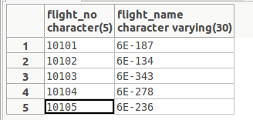

**Q2.**Given the flight number find out route (source,destination)?

**Flight No: 10101**

**SQL: select flight_name,source,destination** from (select * from flight_detail natural join all_path where flight_no='10101')as r1 natural join route;

**Output:**

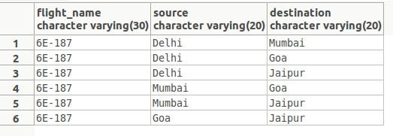

**Q3.**Given a day find out all airports and flight details?

**Day: Monday**

**SQL:** select flight_no,flight_name,depart_time,arrival_time,source,destination from(select * from(select * from flight_detail natural join flight_route) as r1 natural join days where day_name='Monday')as r2 natural join route;

**Output:**

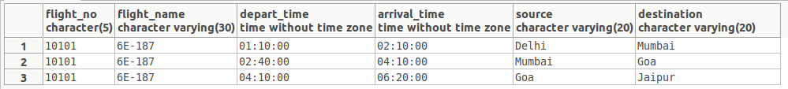

**Q4** Given a route find out all type of fare?**.**

**Route:** Ahmedabad to Channai

**SQL:** select flight_no,fare,passenger_status_name from(select * from fare_detail natural join route)as r1 natural join passenger_status where source='Ahmedabad' and destination='Channai';

**Output:**

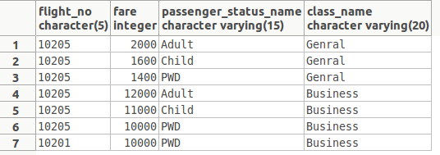

**Q5.**Given a source and destination find out flight details?

**Route:** Delhi to Mumbai

**SQL:** select flight_no,flight_name,source,destination from (select * from flight_detail natural join all_path)as r1 natural join route where source='Delhi' and destination='Mumbai';

**Output:**

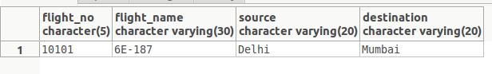

**Q6.**Find out Max fare with flight Detail?

**SQL:** select class_id,flight_no,passenger_status_id,route_id,fare from fare_detail where 7

**Output:**

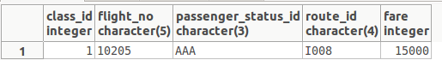

**Q7**.Given PNR find out all details?

**--PNR No: AAAAA00001**

**SQL:** select pnr_no,fname,lname,gender,age,flight_no,flight_name,source,destination,ticket_date,journey_date,fare from(select * from((select * from ticket natural join passenger where pnr_no='AAAAA00001') as r1 natural join

(select * from flight_detail natural join route) as r2)) as r3 natural join fare_detail;

**Output:**

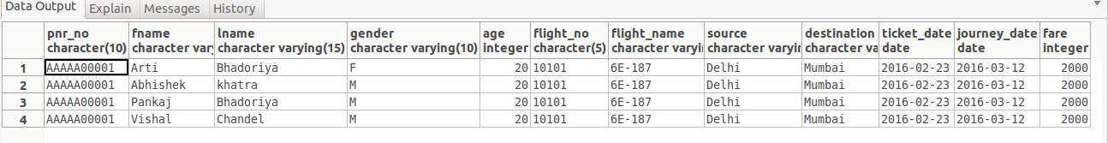

**Q8.** Find out how many ticket book for particular date for Mumbai?

**SQL:** select count(seat_no)as No_of_Ticket from(select * from passenger natural join ticket)as r1 natural join route where ticket_date='2016-02-23' and destination='Mumbai';

**Output:**



**Q9.**Find out how many ticket book for particular date from Delhi to Mumbai?

**SQL:** select count(pnr_no) from(select * from passenger natural join ticket where journey_date='2016-03-12')as r1 natural join route where source='Delhi' and destination='Mumbai';

**Output:**



**Q10.** Find out how many ticket book for particular date?

SQL:

select count(pnr_no)as No_of_Ticket from passenger natural join ticket where ticket_date='2016-02-23';

Output:



**Q11**. Number of flight a particular company?

SQL: c_id,count(select flight_no),c_name from (company natural join flight_detail) group by c_id;

Output:

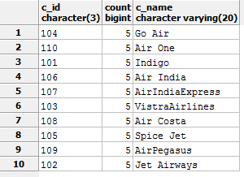

Q12. Find Out User detail those have maximum booking?

SQL: select * from users natural join (select user_id,count(pnr_no) from ticket group by user_id having count(pnr_no) >= all

(select count(pnr_no) from ticket group by user_id)) as r;

Output:



Q13. How many seat book of a particular flight?

SQL: select count(pnr_no) from passenger natural join ticket where journey_date='2016-03-12';

Output:

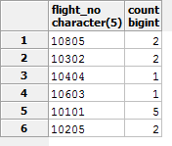

Q14. Update profile

SQL: update users Set fname='Sakshi',lname='Dubay',emailid='skdubay998@gmail.com',contact_no='9865423432',

where fname='name';

Q15. Find out flight detail who going Monday and from Delhi to Mumbai?

SQL: select flight_no,flight_name,source,destination,depart_time,arrival_time,day_name from((select * from flight_detail natural join flight_route)as r1 natural join (select * from all_path natural join route)as r2) as r3 natural join days where day_name='Monday' and source='Delhi' and destination='Mumbai';

Output:



Q16. Find out PNR No which have Booked maximum number of sheets?

SQL: select pnr_no,count(seat_no) as cc from (select * from flight_route join ticket on(flight_route.route_id=ticket.route_id and

flight_route.flight_no=ticket.flight_no )) as r natural join passenger group by pnr_no having count(seat_no) >= all ( select count(seat_no) from

(select * from flight_route join ticket on(flight_route.route_id=ticket.route_id and

flight_route.flight_no=ticket.flight_no)) as r natural join passenger group by pnr_no);

Output:



Q17. Find out the total no ticket of a particular journey date?

SQL: select count(pnr_no) from passenger natural join ticket where journey_date='2016-03-12';

Output:



Q18. Find out the route-id which have maximum flight?

SQL: select route_id,count(*) from flight_route natural join all_path group by route_id having count(*) >= all

(select count(*) from flight_route natural join all_path group by route_id);

Output:

